**HEART DISEASE PREDICTION USING**

**MACHINE LEARNING**

**A MINI PROJECT REPORT**

***Submitted by***

**MANIKANDAN .D (612819104019)**

**NAVEEN KUMAR .S.K (612819104024)**

**SURYA .T (612819104052)**

**THAMIZ .N (612819104053)**

***In partial fulfillment for the award of the degree***

***of***

**BACHELOR OF ENGINEERING**

**IN**

COMPUTER SCIENCE AND ENGINEERING



**VARUVAN VADIVELAN INSTITUTE OF TECHNOLOGY**

DHARMAPURI– 636703

**ANNA UNIVERSITY: CHENNAI 600025**

**JUNE 2022**

**ACKNOWLEDGEMENT**

We like to acknowledge the constant support provided by Chairman **Thiru.M.VADIVELAN,M.B.A,** without him we could not have completed this project in time.

We feel elated to keep on record our heartfelt thanks and gratitude to our Principal **Dr.P.MARIMUTHU,M.E,Ph.D.**Who has been our constant source of inspiration.

We express our regards to **Mr.R.RAJASEKAR,M.E.** Asst.Professor, Head of the Department in Computer Science and Engineering, for providing the necessary facilities whenever needed to carry out the project.

We are also grateful to have **Mrs.** **R.S.ARCHANA VISHVESWARI,M.Tech.** Asst.Professor in Department of Computer Science and Engineering as my project coordinate. His appreciations right from the beginning has been the source of energy.

We would like to thank our guide **Mrs. R.S.ARCHANA VISHVESWARI,M.Tech.** Asst.Professor in Department of Computer Science and Engineering for her valuable guidance and encouragement during the entire span of this project.

**SOURCE CODE:**

**Training_model.py**

import pandas as pd

df = pd.read_csv('dataset.csv')

df

df.isnull().sum()

df.dtypes

x = df.iloc[:, :13]

y = df.iloc[:, 13:14]

x

y

from sklearn.model_selection import train_test_split

x_train, x_test, y_train, y_test = train_test_split(x, y, test_size=0.2)

y_train

from sklearn.neighbors import KNeighborsClassifier

knn = KNeighborsClassifier(n_neighbors=3)

knn.fit(x_train.values, y_train)

knn.predict(x_test)

y_test

knn.score(x_test, y_test)*100

df.columns

import pickle

with open("TR_Model.pkl", "wb") as f:

pickle.dump(knn, f)

import pickle

with open("TR_Model.pkl", "rb") as f:

model=pickle.load(f)

print(f)

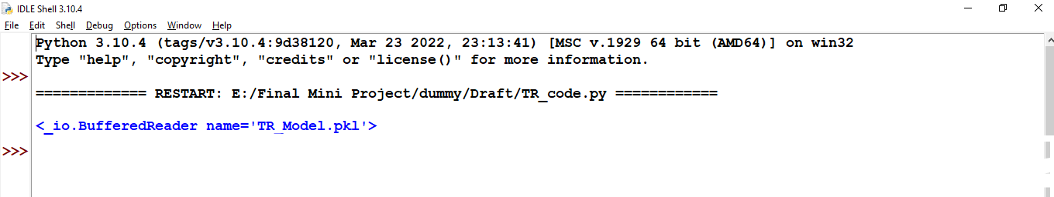

Testing_model.py

import pickle

with open("TR_Model.pkl", "rb") as f:

model=pickle.load(f)

a = int(input("Enter Value Of Age : "))

b = int(input("Enter Gender : "))

c = int(input("Enter Cp : "))

d = int(input("Enter Value Of trestbps : "))

e = int(input("Enter chol : "))

f = int(input("Enter fbs : "))

g = int(input("Enter Value Of restecg : "))

h = int(input("Enter thalach : "))

i = int(input("Enter exang : "))

j = float(input("Enter Value Of oldpeak : "))

k = int(input("Enter slope : "))

l = int(input("Enter ca : "))

m = int(input("Enter thal :"))

if model.predict([[a,b,c,d,e,f,g,h,i,j,k,l,m]])[0] == 1:

print("Affected")

else:

print("Not Affected")

